Chapter 08. Building an Online Shop

In the previous chapter, you created a follow system and built a user activity stream. You also learned how Django signals work and integrated Redis into your project to count image views.

In this chapter, you will start a new Django project that consists of a fully featured online shop. This chapter and the following two chapters will show you how to build the essential functionalities of an e-commerce platform. Your online shop will enable clients to browse products, add them to the cart, apply discount codes, go through the checkout process, pay with a credit card, and obtain an invoice. You will also implement a recommendation engine to recommend products to your customers, and you
will use internationalization to offer your site in multiple languages.

In this chapter, you will learn how to:

- Create a product catalog
- Build a shopping cart using Django sessions
- Create custom template context processors
- Manage customer orders
- Configure Celery in your project with RabbitMQ as a message broker
- Send asynchronous notifications to customers using Celery
- Monitor Celery using Flower

Functional overview
Figure 8.1 shows a representation of the views, templates, and main functionalities that will be built in this chapter:
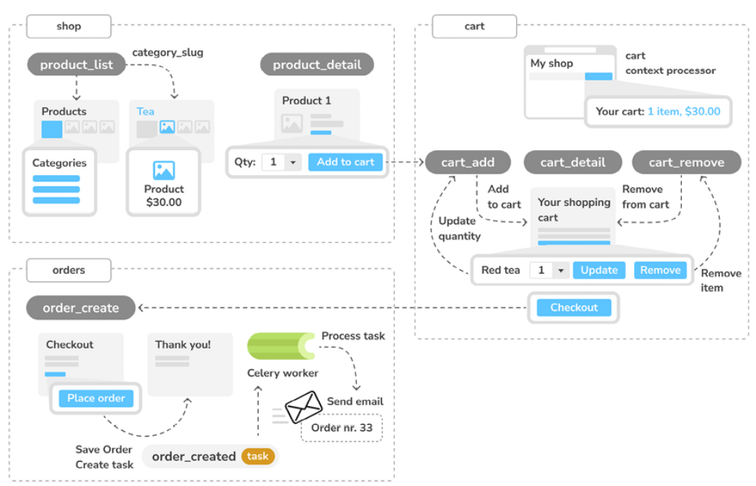
Figure 8.1: Diagram of functionalities built in Chapter 8

In this chapter, you will implement the product_list view to list all products and the product_detail view to display a single product. You will allow filtering products by category in the product_list view using the category_slug parameter. You will implement a shopping cart using sessions and you will build the cart_detail view to display the cart items. You will create the cart_add view to add products to the cart and update quantities, and the cart_remove view to remove products from the cart. You will implement the cart template context processor to display the number of cart items and total cost on the site header. You will also create the order_create view to place orders, and you will use Celery to implement the order_created asynchronous task that sends out an email confirmation
to clients when they place an order. This chapter will provide you with the knowledge to implement user sessions in your application and show you how to work with asynchronous tasks. Both are very common use cases that you can apply to almost any project.

The source code for this chapter can be found at
https://github.com/PacktPublishing/Django-5-byexample/tree/main/Chapter08.

All Python modules used in this chapter are included in the requirements.txt file in the source code that comes along with this chapter. You can follow the instructions to install each Python module below or you can install all requirements at once with the command python -m pip install -r requirements.txt .

Creating an online shop project
Let’s start with a new Django project to build an online shop. Your users will be able to browse through a product catalog and add products to a shopping cart. Finally, they will be able to check out the cart and place an order. This chapter will cover the following functionalities of an online shop:

- Creating the product catalog models, adding them to the administration site, and building the basic views to display the catalog

- Building a shopping cart system using Django sessions to allow users to keep selected products while they browse the site

- Creating the form and functionality to place orders on the site

- Sending an asynchronous email confirmation to users when they place an order

Open a shell and use the following command to create a new virtual environment for this project within the env/ directory:
python -m venv env/myshop

If you are using Linux or macOS, run the following command to activate your virtual environment:
source env/myshop/bin/activate

If you are using Windows, use the following command instead:
.\env\myshop\Scripts\activate

The shell prompt will display your active virtual environment, as follows:
(myshop)laptop:~ zenx$

Install Django in your virtual environment with the following command:
python -m pip install Django~=5.0.4

Start a new project called myshop with an application called shop by opening
a shell and running the following command:
django-admin startproject myshop
The initial project structure has been created. Use the following commands to get into your project directory and create a new application named shop :
cd myshop/
django-admin startapp shop

Edit settings.py and add the following line highlighted in bold to the
INSTALLED_APPS list:
INSTALLED_APPS = [
'django.contrib.admin',
'django.contrib.auth',
'django.contrib.contenttypes',
'django.contrib.sessions',
'django.contrib.messages',
'django.contrib.staticfiles',
'shop.apps.ShopConfig',
]

Your application is now active for this project. Let’s define the models for the product catalog.

Creating product catalog models
The catalog of your shop will consist of products that are organized into different categories. Each product will have a name, an optional description, an optional image, a price, and its availability.

Edit the models.py file of the shop application that you just created and add the following code:
from django.db import models
class Category(models.Model):
name = models.CharField(max_length=200)
slug = models.SlugField(max_length=200, unique=True)
class Meta:
ordering = ['name']
indexes = [
models.Index(fields=['name']),
]
verbose_name = 'category'
verbose_name_plural = 'categories'
def __str__(self):
return self.name
class Product(models.Model):
category = models.ForeignKey(
Category,
related_name='products',
on_delete=models.CASCADE
)
name = models.CharField(max_length=200)
slug = models.SlugField(max_length=200)
image = models.ImageField(
upload_to='products/%Y/%m/%d',
blank=True
)
description = models.TextField(blank=True)
price = models.DecimalField(max_digits=10, decimal_places=2)
available = models.BooleanField(default=True)
created = models.DateTimeField(auto_now_add=True)
updated = models.DateTimeField(auto_now=True)
class Meta:
ordering = ['name']
indexes = [
models.Index(fields=['id', 'slug']),
models.Index(fields=['name']),
models.Index(fields=['-created']),
]
def __str__(self):
return self.name

These are the Category and Product models. The Category model consists of a name field and a unique slug field (unique implies the creation of an index). In the Meta class of the Category model, we have defined an index for the name field.

The Product model fields are as follows:

- category : A ForeignKey to the Category model. This is a one-to-many relationship: a product belongs to one category and a category contains multiple products.

- name : The name of the product.

- slug : The slug for this product to build beautiful URLs.

- image : An optional product image.

- description : An optional description of the product.

- price : This field uses Python’s decimal.Decimal type to store a fixedprecision decimal number. The maximum number of digits (including the decimal places) is set using the max_digits attribute and decimal places with the decimal_places attribute.

- available : A Boolean value that indicates whether the product is available or not. It will be used to enable/disable the product in the catalog.

- created : This field stores when the object was created.
- updated : This field stores when the object was last updated.

For the price field, we use DecimalField instead of FloatField to avoid rounding issues.


Always use DecimalField to store monetary amounts.
FloatField uses Python’s float type internally, whereas
DecimalField uses Python’s Decimal type. By using the
Decimal type, you will avoid float rounding issues.

In the Meta class of the Product model, we have defined a multiple-field index for the id and slug fields. Both fields are indexed together to improve performance for queries that utilize the two fields.

We plan to query products by both id and slug . We have added an index for the name field and an index for the created field. We have used a hyphen before the field name to define the index in descending order.

Figure 8.2 shows the two data models you have created:
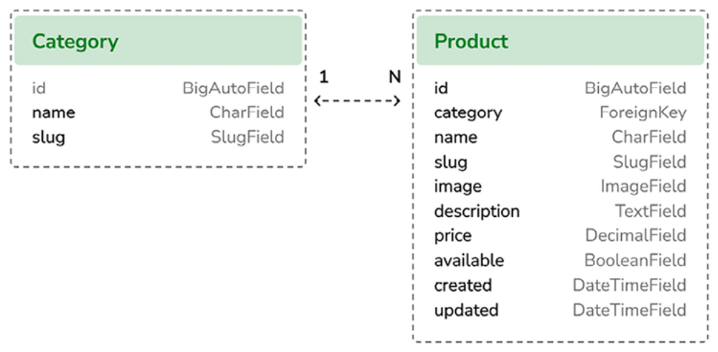
Figure 8.2: Models for the product catalog

In Figure 8.2, you can see the different fields of the data models and the oneto- many relationship between the Category and the Product models.

These models will result in the following database tables displayed in Figure 8.3:
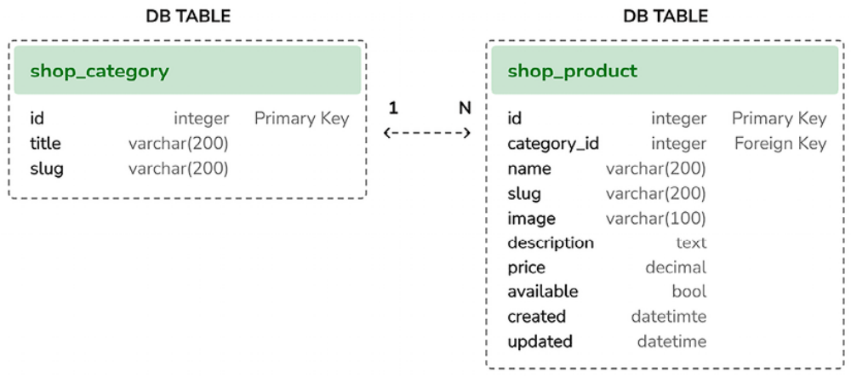
Figure 8.3: Database tables for the product catalog models

The one-to-many relationship between both tables is defined with the category_id field in the shop_product table, which is used to store the ID of the related Category for each Product object.

Let’s create the initial database migrations for the shop application. Since you are going to deal with images in your models, you will need to install the Pillow library. Remember that in Chapter 4, Building a Social Website, you learned how to install the Pillow library to manage images. Open the shell and install Pillow with the following command:
python -m pip install Pillow==10.3.0

Now run the next command to create initial migrations for your project:
python manage.py makemigrations

You will see the following output:
Migrations for 'shop':
shop/migrations/0001_initial.py
- Create model Category
- Create model Product

Run the next command to sync the database:
python manage.py migrate

You will see output that includes the following line:
Applying shop.0001_initial... OK

The database is now synced with your models.

Registering catalog models on the administration site
Let’s add your models to the administration site so that you can easily manage categories and products. Edit the admin.py file of the shop application and add the following code to it:
from django.contrib import admin
from .models import Category, Product
@admin.register(Category)
class CategoryAdmin(admin.ModelAdmin):
list_display = ['name', 'slug']
prepopulated_fields = {'slug': ('name',)}
@admin.register(Product)
class ProductAdmin(admin.ModelAdmin):
list_display = [
'name',
'slug',
'price',
'available',
'created',
'updated'
]
list_filter = ['available', 'created', 'updated']
list_editable = ['price', 'available']
prepopulated_fields = {'slug': ('name',)}

Remember that you use the prepopulated_fields attribute to specify fields where the value is automatically set using the value of other fields. As you have seen before, this is convenient for generating slugs.

You use the list_editable attribute in the ProductAdmin class to set the fields that can be edited from the list display page of the administration site. This will allow you to edit multiple rows at once. Any field in list_editable must also be listed in the list_display attribute since only
the fields displayed can be edited.

Now create a superuser for your site using the following command:
python manage.py createsuperuser

Enter the desired username, email, and password. Run the development server with the following command:
python manage.py runserver
Open http://127.0.0.1:8000/admin/shop/product/add/ in your browserand log in with the user that you just created. Add a new category and product using the administration interface. The Add product form should look as follows:
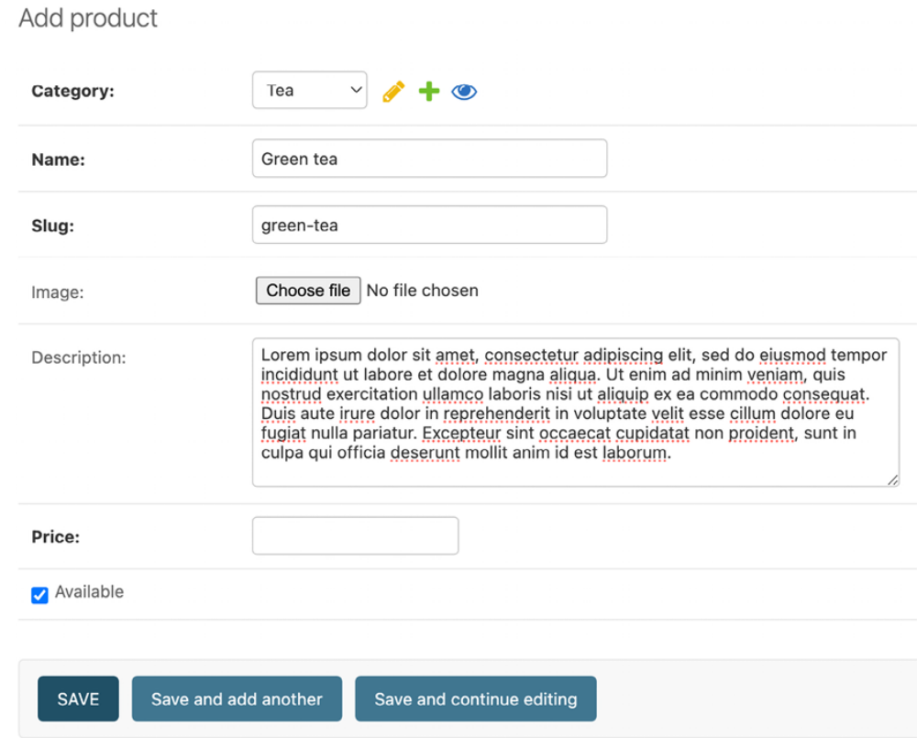
Figure 8.4: The product creation form

Click on the SAVE button. The product change list page of the administration page will then look like this:
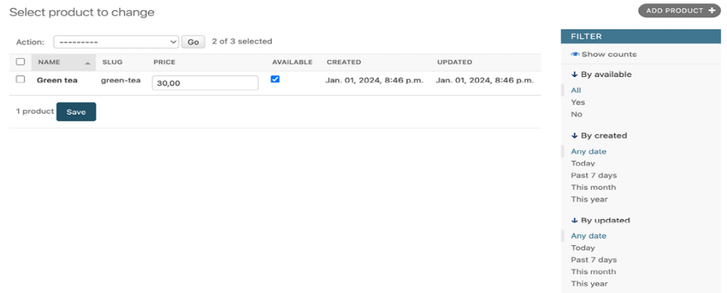
Figure 8.5: The product change list page
Building catalog views
In order to display the product catalog, you need to create a view to list all the products or filter products by a given category. Edit the views.py file of the shop application and add the following code highlighted in bold:
from django.shortcuts import get_object_or_404, render
from .models import Category, Product
def product_list(request, category_slug=None):
category = None
categories = Category.objects.all()
products = Product.objects.filter(available=True)
if category_slug:
category = get_object_or_404(Category, slug=category_slu
products = products.filter(category=category)
return render(
request,
'shop/product/list.html',
{
'category': category,
'categories': categories,
'products': products
}
)

In the preceding code, you filter the QuerySet with available=True to retrieve only available products. You use an optional category_slug parameter to optionally filter products by a given category.

You also need a view to retrieve and display a single product. Add the following view to the views.py file:
def product_detail(request, id, slug):
product = get_object_or_404(
Product, id=id, slug=slug, available=True
)
return render(
request,
shop/product/detail.html',
{'product': product}
)

The product_detail view expects the id and slug parameters in order to retrieve the Product instance. You can get this instance just through the ID since it’s a unique attribute. However, you include the slug in the URL to build SEO-friendly URLs for products.

After building the product list and detail views, you have to define URL patterns for them. Create a new file inside the shop application directory and name it urls.py . Add the following code to it:
from django.urls import path
from . import views
app_name = 'shop'
urlpatterns = [
path('', views.product_list, name='product_list'),
path(
'<slug:category_slug>/',
views.product_list,
name='product_list_by_category'
),
path(
'<int:id>/<slug:slug>/',
views.product_detail,
name='product_detail'
),
]

These are the URL patterns for your product catalog. You have defined two different URL patterns for the product_list view: a pattern named product_list , which calls the product_list view without any parameters, and a pattern named product_list_by_category , which provides a category_slug parameter to the view for filtering products according to a given category. You added a pattern for the product_detail view, which passes the id and slug parameters to the view in order to retrieve a specific product.

Edit the urls.py file of the myshop project to make it look like this:
from django.contrib import admin
from django.urls import include, path
urlpatterns = [
path('admin/', admin.site.urls),
path('', include('shop.urls', namespace='shop')),
]

In the main URL patterns of the project, you include URLs for the shop application under a custom namespace named shop .

Next, edit the models.py file of the shop application, import the reverse() function, and add a get_absolute_url() method to the Category and Product models, as follows. The new code is highlighted in bold:
from django.db import models
from django.urls import reverse
class Category(models.Model):
# ...
def get_absolute_url(self):
return reverse(
'shop:product_list_by_category', args=[self.slug]
)
class Product(models.Model):
# ...
def get_absolute_url(self):
return reverse('shop:product_detail', args=[self.id, self.slug]

As you already know, get_absolute_url() is the convention to retrieve the URL for a given object. Here, you use the URL patterns that you just defined in the urls.py file.

Creating catalog templates
Now you need to create templates for the product list and detail views.

Create the following directory and file structure inside the shop application directory:
templates/
shop/
base.html
product/
list.html
detail.html

You need to define a base template and then extend it in the product list and detail templates. Edit the shop/base.html template and add the following code to it:
{% load static %}
<!DOCTYPE html>
<html>
<head>
<meta charset="utf-8" />
<title>{% block title %}My shop{% endblock %}</title>
<link href="{% static "css/base.css" %}" rel="stylesheet">
</head>
<body>
<div id="header">
<a href="/" class="logo">My shop</a>
</div>
<div id="subheader">
<div class="cart">
Your cart is empty.
</div>
</div>
<div id="content">
{% block content %}
{% endblock %}
</div>
</body>
</html>

This is the base template that you will use for your shop. In order to include the CSS styles and images that are used by the templates, you need to copy the static files that accompany this chapter, which are located in the static/ directory of the shop application. Copy them to the same location in your project. You can find the contents of the directory at https://github.com/PacktPublishing/Django-5-by Example/tree/main/Chapter08/myshop/shop/static.

Edit the shop/product/list.html template and add the following code to it:
{% extends "shop/base.html" %}
{% load static %}
{% block title %}
{% if category %}{{ category.name }}{% else %}Products{% endif
{% endblock %}
{% block content %}
<div id="sidebar">
<h3>Categories</h3>
<ul>
<li {% if not category %}class="selected"{% endif %}>
<a href="{% url "shop:product_list" %}">All</a>
</li>
{% for c in categories %}
<li {% if category.slug == c.slug %}class="selected"
{% endif %}>
<a href="{{ c.get_absolute_url }}">{{ c.name }}</a>
</li>
{% endfor %}
</ul>
</div>
<div id="main" class="product-list">
<h1>{% if category %}{{ category.name }}{% else %}Products
{% endif %}</h1>
{% for product in products %}
<div class="item">
<a href="{{ product.get_absolute_url }}">
<img src="{% if product.image %}{{ product.image.url }}{% else %
</a>
<a href="{{ product.get_absolute_url }}">{{ product.name }}</a>
<br>
${{ product.price }}
</div>
{% endfor %}
</div>
{% endblock %}

Make sure that no template tag is split across multiple lines.

This is the product list template. It extends the shop/base.html template and uses the categories context variable to display all the categories in a sidebar, and products to display the products of the current page. The same template is used for both listing all available products and listing products filtered by category. Since the image field of the Product model can be blank, you need to provide a default image for the products that don’t have an image. The image is located in your static files directory with the relative
path img/no_image.png .

Since you are using ImageField to store product images, you need the development server to serve uploaded image files.

Edit the settings.py file of myshop and add the following settings:
MEDIA_URL = 'media/'
MEDIA_ROOT = BASE_DIR / 'media'
MEDIA_URL is the base URL that serves media files uploaded by users.
MEDIA_ROOT is the local path where these files reside, which you build by dynamically prepending the BASE_DIR variable.

For Django to serve the uploaded media files using the development server, edit the main urls.py file of myshop and add the following code highlighted in bold:
from django.conf import settings
from django.conf.urls.static import static
from django.contrib import admin
from django.urls import include, path
urlpatterns = [
path('admin/', admin.site.urls),
path('', include('shop.urls', namespace='shop')),
]
if settings.DEBUG:
urlpatterns += static(
settings.MEDIA_URL, document_root=settings.MEDIA_ROOT
)

Remember that you only serve static files this way during development. In a production environment, you should never serve static files with Django; the Django development server doesn’t serve static files in an efficient manner. Chapter 17, Going Live, will teach you how to serve static files in a production environment.

Run the development server with the following command:
python manage.py runserver

Add a couple of products to your shop using the administration site and open
http://127.0.0.1:8000/ in your browser. You will see the product list page,

which will look similar to this:
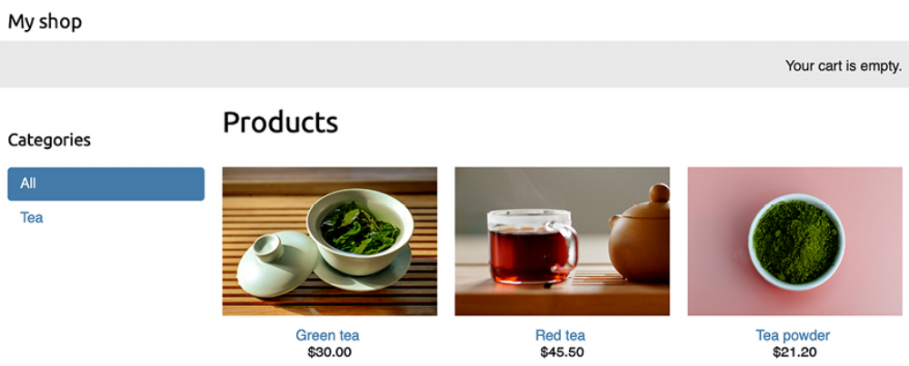
Figure 8.6: The product list page


Credits for images in this chapter:

- Green tea: Photo by Jia Ye on Unsplash
- Red tea: Photo by Manki Kim on Unsplash
- Tea powder: Photo by Phuong Nguyen on Unsplash



If you create a product using the administration site and don’t upload an image for it, the default no_image.png image will be displayed instead:
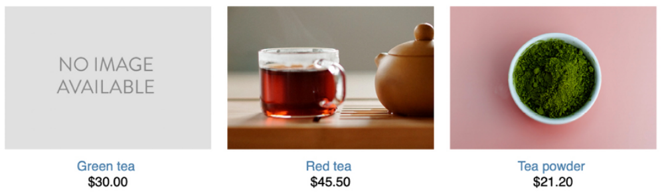
Figure 8.7: The product list displaying a default image for products that have no image

Edit the shop/product/detail.html template and add the following code to it:
{% extends "shop/base.html" %}
{% load static %}
{% block title %}
{{ product.name }}
{% endblock %}
{% block content %}
<div class="product-detail">
<img src="{% if product.image %}{{ product.image.url }}{% else %
{% static "img/no_image.png" %}{% endif %}">
<h1>{{ product.name }}</h1>
<h2>
<a href="{{ product.category.get_absolute_url }}">
{{ product.category }}
</a>
</h2>
<p class="price">${{ product.price }}</p>
{{ product.description|linebreaks }}
</div>
{% endblock %}

In the preceding code, you call the get_absolute_url() method on the related category object to display the available products that belong to the same category.

Now open http://127.0.0.1:8000/ in your browser and click on any product to see the product detail page. It will look as follows:
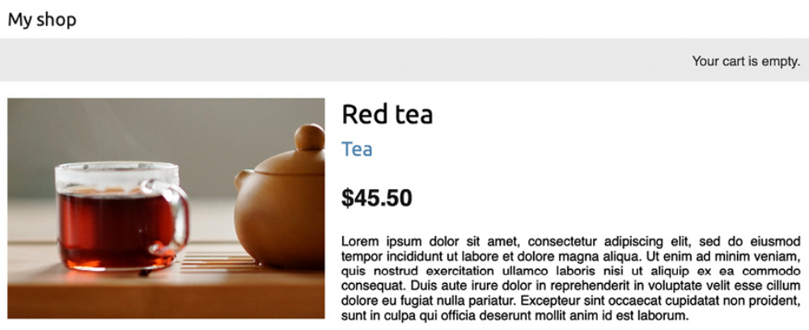
Figure 8.8: The product detail page

You have now created a basic product catalog. Next, you will implement a shopping cart that allows users to add any product to it while browsing the online shop.

Building a shopping cart
After building the product catalog, the next step is to create a shopping cart so that users can pick the products that they want to purchase. A shopping cart allows users to select products and set the amount they want to order, and then store this information temporarily while they browse the site until they eventually place an order. The cart has to be persisted in the session so that the cart items are maintained during a user’s visit.
You will use Django’s session framework to persist the cart. The cart will be kept in the session until it finishes or the user checks out the cart. You will also need to build additional Django models for the cart and its items.

Using Django sessions
Django provides a session framework that supports anonymous and user sessions. The session framework allows you to store arbitrary data for each visitor. Session data is stored on the server side, and cookies contain the session ID unless you use the cookie-based session engine. The session middleware manages the sending and receiving of cookies. The default session engine stores session data in the database, but you can choose other session engines.

To use sessions, you have to make sure that the MIDDLEWARE setting of your project contains django.contrib.sessions.middleware.SessionMiddleware . This middleware manages sessions. It’s added by default to the MIDDLEWARE setting when you create a new project using the startproject command.

The session middleware makes the current session available in the request object. You can access the current session using request.session , treating it like a Python dictionary to store and retrieve session data. The session dictionary accepts any Python object by default that can be serialized to JSON. You can set a variable in the session like this:
request.session['foo'] = 'bar'

You can retrieve a session key as follows:
request.session.get('foo')

You can delete a key you previously stored in the session as follows:
del request.session['foo']

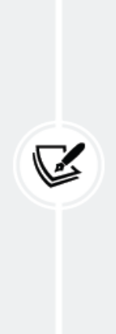
When users log in to the site, their anonymous session is lost,
and a new session is created for authenticated users. If you
store items in an anonymous session that you need to keep
after the user logs in, you will have to copy the old session
data into the new session. You can do this by retrieving the
session data before you log in the user using the login()
function of the Django authentication system and storing it in
the session after that.

Session settings
There are several settings you can use to configure sessions for your project. The most important is SESSION_ENGINE . This setting allows you to set the place where sessions are stored. By default, Django stores sessions in the database using the Session model of the django.contrib.sessions application.

Django offers the following options for storing session data:

  - Database sessions: Session data is stored in the database. This is the default session engine.
- File-based sessions: Session data is stored in the filesystem.

- Cached sessions: Session data is stored in a cache backend. You can specify cache backends using the CACHES setting. Storing session data in a cache system provides the best performance.

- Cached database sessions: Session data is stored in a write-through cache and database. Reads only use the database if the data is not already in the cache.

- Cookie-based sessions: Session data is stored in the cookies that are sent to the browser.
For better performance use a cache-based session engine.
Django supports Memcached out of the box and you can find
third-party cache backends for Redis and other cache
systems.



You can customize sessions with specific settings. Here are some of the important session-related settings:

  - SESSION_COOKIE_AGE : The duration of session cookies in seconds. The default value is 1209600 (two weeks).
- SESSION_COOKIE_DOMAIN : The domain used for session cookies. Set this to mydomain.com to enable cross-domain cookies or use None for a standard domain cookie.

- SESSION_COOKIE_HTTPONLY : Whether to use the HttpOnly flag on the session cookie. If this is set to True , client-side JavaScript will not be able to access the session cookie. The default value is True for increased security against user session hijacking.

- SESSION_COOKIE_SECURE : A Boolean indicating that the cookie should only be sent if the connection is an HTTPS connection. The default value is False .

- SESSION_EXPIRE_AT_BROWSER_CLOSE : A Boolean indicating that the session has to expire when the browser is closed. The default value is False .

- SESSION_SAVE_EVERY_REQUEST : A Boolean that, if True , will save the session to the database on every request. The session expiration is also updated each time it’s saved. The default value is False .

You can see all the session settings and their default values at
https://docs.djangoproject.com/en/5.0/ref/settings/#sessions.

Session expiration
You can choose to use browser-length sessions or persistent sessions using the SESSION_EXPIRE_AT_BROWSER_CLOSE setting. This is set to False by default, forcing the session duration to the value stored in the SESSION_COOKIE_AGE setting. If you set SESSION_EXPIRE_AT_BROWSER_CLOSE to True , the session will expire when the user closes the browser, and the SESSION_COOKIE_AGE setting will not have any effect.

You can use the set_expiry() method of request.session to overwrite the duration of the current session.

Storing shopping carts in sessions
You need to create a simple structure that can be serialized to JSON for storing cart items in a session. The cart has to include the following data for each item contained in it:
- The ID of a Product instance
- The quantity selected for the product
- The unit price for the product

Since product prices may vary, let’s take the approach of storing the product’s price along with the product itself when it’s added to the cart. By doing so, you use the current price of the product when users add it to their cart, no matter whether the product’s price is changed afterward. This means that the price that the item has when the client adds it to the cart is maintained for that client in the session until checkout is completed or the session finishes.

Next, you have to build functionality to create shopping carts and associate then with sessions. This has to work as them with sessions. This has to work as follows:

- When a cart is needed, you check whether a custom session key is set. If no cart is set in the session, you create a new cart and save it in the cart session key.

- For successive requests, you perform the same check and get the cart items from the cart session key. You retrieve the cart items from the session and their related Product objects from the database.

Edit the settings.py file of your project and add the following setting to it:
CART_SESSION_ID = 'cart'

This is the key that you are going to use to store the cart in the user session. Since Django sessions are managed per visitor, you can use the same cart session key for all sessions.

Let’s create an application for managing shopping carts. Open the terminal and create a new application, running the following command from the project directory:
python manage.py startapp cart

Then, edit the settings.py file of your project and add the new application to the INSTALLED_APPS setting with the following line highlighted in bold:
INSTALLED_APPS = [
# ...
'cart.apps.CartConfig',
'shop.apps.ShopConfig',
]

Create a new file inside the cart application directory and name it cart.py .
Add the following code to it:
from decimal import Decimal
from django.conf import settings
from shop.models import Product
class Cart:
def __init__(self, request):
"""
Initialize the cart.
"""
self.session = request.session
cart = self.session.get(settings.CART_SESSION_ID)
if not cart:
# save an empty cart in the session
cart = self.session[settings.CART_SESSION_ID] = {}
self.cart = cart

This is the Cart class that will allow you to manage the shopping cart. You require the cart to be initialized with a request object. You store the current session using self.session = request.session to make it accessible to the other methods of the Cart class.

First, you try to get the cart from the current session using self.session.get(settings.CART_SESSION_ID) . If no cart is present in the session, you create an empty cart by setting an empty dictionary in the session.

You will build your cart dictionary with product IDs as keys, and for each product key, a dictionary will be a value that includes quantity and price. By doing this, you can guarantee that a product will not be added more than once to the cart. This way, you can also simplify retrieving cart items.

Let’s create a method to add products to the cart or update their quantity.
Add the following add() and save() methods to the Cart class:
class Cart:
# ...
def add(self, product, quantity=1, override_quantity=False):
"""
Add a product to the cart or update its quantity.
"""
product_id = str(product.id)
if product_id not in self.cart:
self.cart[product_id] = {
'quantity': 0,
'price': str(product.price)
}
if override_quantity:
self.cart[product_id]['quantity'] = quantity
else:
self.cart[product_id]['quantity'] += quantity
self.save()
def save(self):
# mark the session as "modified" to make sure it gets saved
self.session.modified = True

The add() method takes the following parameters as input:

- product : The product instance to add or update in the cart.

- quantity : An optional integer with the product quantity. This defaults to 1 .

- override_quantity : A Boolean that indicates whether the quantity needs to be overridden with the given quantity (True ) or whether the new quantity has to be added to the existing quantity (False ).

You use the product ID as a key in the cart’s content dictionary. You convert the product ID into a string because Django uses JSON to serialize session data, and JSON only allows string key names. The product ID is the key, and the value that you persist is a dictionary with quantity and price figures for the product. The product’s price is converted from decimal into a string to serialize it. Finally, you call the save() method to save the cart in the session.

The save() method marks the session as modified using session.modified = True . This tells Django that the session has changed and needs to be saved.

You also need a method for removing products from the cart. Add the following method to the Cart class:
class Cart:
# ...
def remove(self, product):
"""
Remove a product from the cart.
"""
product_id = str(product.id)
if product_id in self.cart:
del self.cart[product_id]
self.save()

The remove() method removes a given product from the cart dictionary and calls the save() method to update the cart in the session.

You will have to iterate through the items contained in the cart and access the related Product instances. To do so, you can define an __iter__() method in your class. Add the following method to the Cart class:
class Cart:
# ...
def __iter__(self):
"""
Iterate over the items in the cart and get the products
from the database.
"""
product_ids = self.cart.keys()
# get the product objects and add them to the cart
products = Product.objects.filter(id__in=product_ids)
cart = self.cart.copy()
for product in products:
cart[str(product.id)]['product'] = product
for item in cart.values():
item['price'] = Decimal(item['price'])
item['total_price'] = item['price'] * item['quantity
yield item

In the __iter__() method, you retrieve the Product instances that are present in the cart to include them in the cart items. You copy the current cart in the cart variable and add the Product instances to it. Finally, you iterate over the cart items, converting each item’s price back into decimal, and adding a total_price attribute to each item. This __iter__() method will allow you to easily iterate over the items in the cart in views and templates.

You also need a way to return the total number of items in the cart. When the len() function is executed on an object, Python calls its __len__() method to retrieve its length. Next, you are going to define a custom __len__() method to return the total number of items stored in the cart.

Add the following __len__() method to the Cart class:
class Cart:
# ...
def __len__(self):
"""
Count all items in the cart.
"""
return sum(item['quantity'] for item in self.cart.values())

You return the sum of the quantities of all the cart items.

Add the following method to calculate the total cost of the items in the cart:
class Cart:
# ...
def get_total_price(self):
return sum(
Decimal(item['price']) * item['quantity']
for item in self.cart.values()
)

Finally, add a method to clear the cart session:
class Cart:
# ...
def clear(self):
# remove cart from session
del self.session[settings.CART_SESSION_ID]
self.save()

Your Cart class is now ready to manage shopping carts.

Creating shopping cart views
Now that you have a Cart class to manage the cart, you need to create the views to add, update, or remove items from it. You need to create the following views:

  - A view to add or update items in the cart that can handle current and new quantities
  - A view to remove items from the cart
- A view to display cart items and totals

Adding items to the cart
To add items to the cart, you need a form that allows the user to select a quantity. Create a forms.py file inside the cart application directory and add the following code to it:
from django import forms
PRODUCT_QUANTITY_CHOICES = [(i, str(i)) for i in range(1, 21)]
class CartAddProductForm(forms.Form):
quantity = forms.TypedChoiceField(
choices=PRODUCT_QUANTITY_CHOICES,
coerce=int
)
override = forms.BooleanField(
required=False,
initial=False,
widget=forms.HiddenInput
)

You will use this form to add products to the cart. Your CartAddProductForm class contains the following two fields:

- quantity : This allows the user to select a quantity between 1 and 20. You use a TypedChoiceField field with coerce=int to convert the input into an integer.

- override : This allows you to indicate whether the quantity has to be added to any existing quantity in the cart for this product (False ) or whether the existing quantity has to be overridden with the given quantity (True ). You use a HiddenInput widget for this field since you don’t want to display it to the user.
Let’s create a view for adding items to the cart. Edit the views.py file of the
cart application and add the following code highlighted in bold:
from django.shortcuts import get_object_or_404, redirect, render
from django.views.decorators.http import require_POST
from shop.models import Product
from .cart import Cart
from .forms import CartAddProductForm
@require_POST
def cart_add(request, product_id):
cart = Cart(request)
product = get_object_or_404(Product, id=product_id)
form = CartAddProductForm(request.POST)
if form.is_valid():
cd = form.cleaned_data
cart.add(
product=product,
quantity=cd['quantity'],
override_quantity=cd['override']
)
return redirect('cart:cart_detail')

This is the view for adding products to the cart or updating quantities for existing products. You use the require_POST decorator to allow only POST requests. The view receives the product ID as a parameter. You retrieve the Product instance with the given ID and validate CartAddProductForm . If the form is valid, you either add or update the product in the cart. The view redirects to the cart_detail URL, which will display the contents of the cart. You are going to create the cart_detail view shortly.

You also need a view to remove items from the cart. Add the following code to the views.py file of the cart application:
@require_POST
def cart_remove(request, product_id):
cart = Cart(request)
product = get_object_or_404(Product, id=product_id)
cart.remove(product)
return redirect('cart:cart_detail')

The cart_remove view receives the product ID as a parameter. You use the require_POST decorator to allow only POST requests. You retrieve the Product instance with the given ID and remove the product from the cart. Then, you redirect the user to the cart_detail URL.

Finally, you need a view to display the cart and its items. Add the following view to the views.py file of the cart application:
def cart_detail(request):
cart = Cart(request)
return render(request, 'cart/detail.html', {'cart': cart})
The cart_detail view gets the current cart to display it. You have created views to add items to the cart, update quantities, remove items from the cart, and display the cart’s contents. Let’s add URL patterns for these views. Create a new file inside the cart application directory and name it urls.py . Add the following URL patterns to it:
from django.urls import path
from . import views
app_name = 'cart'
urlpatterns = [
path('', views.cart_detail, name='cart_detail'),
path('add/<int:product_id>/', views.cart_add, name='cart_add
path(
'remove/<int:product_id>/',
views.cart_remove,
name='cart_remove'
),
]

Edit the main urls.py file of the myshop project and add the following URL pattern highlighted in bold to include the cart URLs:
urlpatterns = [
path('admin/', admin.site.urls),
path('cart/', include('cart.urls', namespace='cart')),
path('', include('shop.urls', namespace='shop')),
]

Make sure that you include this URL pattern before the shop.urls pattern since it’s more restrictive than the latter.

Building a template to display the cart
The cart_add and cart_remove views don’t render any templates, but you need to create a template for the cart_detail view to display cart items and totals.

Create the following file structure inside the cart application directory:
templates/
cart/
detail.html

Edit the cart/detail.html template and add the following code to it:
{% extends "shop/base.html" %}
{% load static %}
{% block title %}
Your shopping cart
{% endblock %}
{% block content %}
<h1>Your shopping cart</h1>
<table class="cart">
<thead>
<tr>
<th>Image</th>
<th>Product</th>
<th>Quantity</th>
<th>Remove</th>
<th>Unit price</th>
<th>Price</th>
</tr>
</thead>
<tbody>
{% for item in cart %}
{% with product=item.product %}
<tr>
<td>
<a href="{{ product.get_absolute_url }}">
<img src="{% if product.image %}{{ product.image.url }}
{% else %}{% static "img/no_image.png" %}{% endi
</a>
</td>
<td>{{ product.name }}</td>
<td>{{ item.quantity }}</td>
<td>
<form action="{% url "cart:cart_remove" product.id %}" method="p
<input type="submit" value="Remove">
{% csrf_token %}
</form>
</td>
<td class="num">${{ item.price }}</td>
<td class="num">${{ item.total_price }}</td>
</tr>
{% endwith %}
{% endfor %}
<tr class="total">
<td>Total</td>
<td colspan="4"></td>
<td class="num">${{ cart.get_total_price }}</td>
</tr>
</tbody>
</table>
<p class="text-right">
<a href="{% url "shop:product_list" %}" class="button
light">Continue shopping</a>
<a href="#" class="button">Checkout</a>
</p>
{% endblock %}

Make sure that no template tag is split across multiple lines.

This is the template that is used to display the cart’s contents. It contains a table with the items stored in the current cart. You allow users to change the quantity of the selected products using a form that is posted to the cart_add view. You also allow users to remove items from the cart by providing a Remove button for each of them. Finally, you use an HTML form with an action attribute that points to the cart_remove URL including the product ID.

Adding products to the cart
Now you need to add an Add to cart button to the product detail page. Edit the views.py file of the shop application and add CartAddProductForm to the product_detail view, as follows:
from cart.forms import CartAddProductForm
# ...
def product_detail(request, id, slug):
product = get_object_or_404(
Product, id=id, slug=slug, available=True
)
cart_product_form = CartAddProductForm()
return render(
request,
'shop/product/detail.html',
{'product': product, 'cart_product_form': cart_product_f
)

Edit the shop/product/detail.html template of the shop application and add the following form to the product price, as follows. New lines are highlighted in bold:
...
<p class="price">${{ product.price }}</p>
<form action="{% url "cart:cart_add" product.id %}" method="post
{{ cart_product_form }}
{% csrf_token %}
<input type="submit" value="Add to cart">
</form>
{{ product.description|linebreaks }}
...

Run the development server with the following command:
python manage.py runserver

Now open http://127.0.0.1:8000/ in your browser and navigate to a product’s detail page. It will contain a form to choose a quantity before adding the product to the cart. The page will look like this:
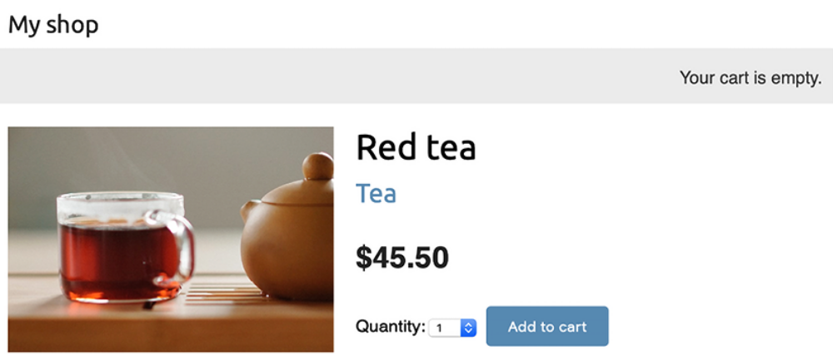
Figure 8.9: The product detail page, including the Add to cart button

Choose a quantity and click on the Add to cart button. The form is submitted to the cart_add view via POST . The view adds the product to the cart in the session, including its current price and the selected quantity. Then, it redirects the user to the cart detail page, which will look like Figure 8.10:
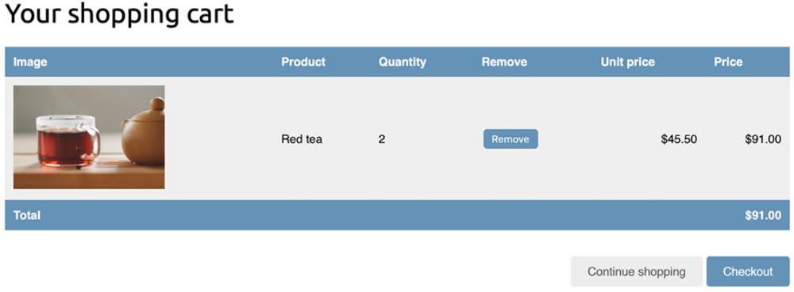
Figure 8.10: The cart detail page

Updating product quantities in the cart
When users see the cart, they might want to change product quantities before placing an order. You are going to allow users to change quantities from the cart detail page.

Edit the views.py file of the cart application and add the following lines highlighted in bold to the cart_detail view:
def cart_detail(request):
cart = Cart(request)
for item in cart:
item['update_quantity_form'] = CartAddProductForm(
initial={'quantity': item['quantity'], 'override': T
)
return render(request, 'cart/detail.html', {'cart': cart})

You create an instance of CartAddProductForm for each item in the cart to allow changing product quantities. You initialize the form with the current item quantity and set the override field to True so that when you submit the form to the cart_add view, the current quantity is replaced with the new one.

Now edit the cart/detail.html template of the cart application and find the following line:
<td>{{ item.quantity }}</td>

the previous line with the following code:
<td>
<form action="{% url "cart:cart_add" product.id %}" method="pos
{{ item.update_quantity_form.quantity }}
{{ item.update_quantity_form.override }}
<input type="submit" value="Update">
{% csrf_token %}
</form>
</td>

Run the development server with the following command:
python manage.py runserver

Open http://127.0.0.1:8000/cart/ in your browser.

You will see a form to edit the quantity for each cart item, as follows:
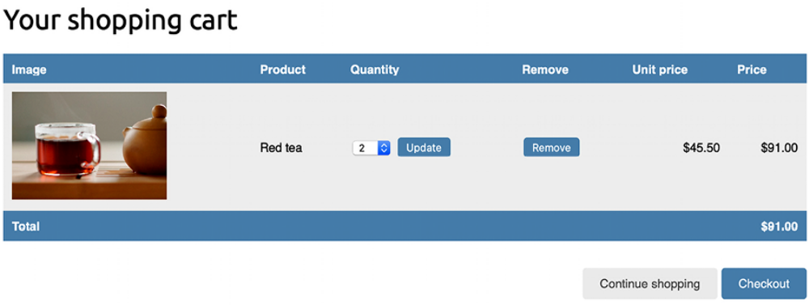
Figure 8.11: The cart detail page, including the form to update product quantities

Change the quantity of an item and click on the Update button to test the new functionality. You can also remove an item from the cart by clicking the Remove button.
Creating a context processor for the current cart
You might have noticed that the message Your cart is empty is displayed in the header of the site, even when the cart contains items. You should display the total number of items in the cart and the total cost instead. Since this has to be displayed on all pages, you need to build a context processor to include the current cart in the request context, regardless of the view that processes the request.

Context processors
A context processor is a Python function that takes the request object as an argument and returns a dictionary that gets added to the request context.

Context processors come in handy when you need to make something available globally to all templates.

By default, when you create a new project using the startproject command, your project contains the following template context processors in the context_processors option inside the TEMPLATES setting:

- django.template.context_processors.debug : This sets the Boolean debug and sql_queries variables in the context, representing the list of SQL queries executed in the request.

- django.template.context_processors.request : This sets the request variable in the context.

- django.contrib.auth.context_processors.auth : This sets the user
variable in the request.

- django.contrib.messages.context_processors.messages : This sets a messages variable in the context containing all the messages that have been generated using the messages framework.

Django also enables django.template.context_processors.csrf to avoid cross-site request forgery (CSRF) attacks. This context processor is not present in the settings, but it is always enabled and can’t be turned off for security reasons.
You can see the list of all built-in context processors at
https://docs.djangoproject.com/en/5.0/ref/templates/api/#built-in-template-context-processors.
Setting the cart in the request context
Let’s create a context processor to set the current cart in the request context. With it, you will be able to access the cart in any template.

Create a new file inside the cart application directory and name it context_processors.py . Context processors can reside anywhere in your code but creating them here will keep your code well organized. Add the following code to the file:
from .cart import Cart
def cart(request):
return {'cart': Cart(request)}

In your context processor, you instantiate the cart using the request object and make it available for the templates as a variable named cart .

Edit the settings.py file of your project and add cart.context_processors.cart to the context_processors option inside the TEMPLATES setting, as follows. The new line is highlighted in bold:
TEMPLATES = [
{
'BACKEND': 'django.template.backends.django.DjangoTempla
'DIRS': [],
'APP_DIRS': True,
'OPTIONS': {
'context_processors': [
'django.template.context_processors.debug',
'django.template.context_processors.request',
'django.contrib.auth.context_processors.auth',
'django.contrib.messages.context_processors.mess
'cart.context_processors.cart',
],
},
},
]

The cart context processor will be executed every time a template is rendered using Django’s RequestContext . The cart variable will be set in the context of your templates. You can read more about RequestContext at https://docs.djangoproject.com/en/5.0/ref/templates/api/#django.template.RequestContext.
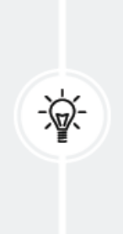
Context processors are executed in all the requests that use RequestContext . You might want to create a custom template tag instead of a context processor if your functionality is not needed in all templates, especially if it involves database
queries.

Next, edit the shop/base.html template of the shop application and find the following lines:
<div class="cart">
Your cart is empty.
</div>

Replace the previous lines with the following code:
<div class="cart">
{% with total_items=cart|length %}
{% if total_items > 0 %}
Your cart:
<a href="{% url "cart:cart_detail" %}">
{{ total_items }} item{{ total_items|pluralize }},
${{ cart.get_total_price }}
</a>
{% else %}
Your cart is empty.
{% endif %}
{% endwith %}
</div>

Restart the development server with the following command:
python manage.py runserver

Open http://127.0.0.1:8000/ in your browser and add some products to the cart.

In the header of the website, you can now see the total number of items in the cart and the total cost, as follows:
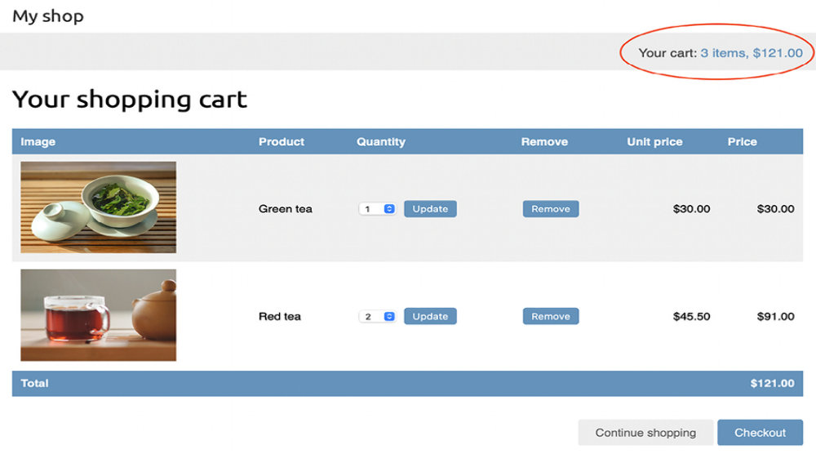
Figure 8.12: The site header displaying the current items in the cart
Congratulations! You have completed the shopping cart functionality. This is a significant milestone in your online shop project. Next, you are going to create the functionality to register customer orders, which is another foundational element of any e-commerce platform.

Registering customer orders
When a shopping cart is checked out, you need to save an order in the database. Orders will contain information about customers and the products they are buying.
Create a new application for managing customer orders using the following
command:
python manage.py startapp orders

Edit the settings.py file of your project and add the new application to the
INSTALLED_APPS setting, as follows:
INSTALLED_APPS = [
# ...
'cart.apps.CartConfig',
'orders.apps.OrdersConfig',
'shop.apps.ShopConfig',
]
You have activated the orders application.

Creating order models
You will need a model to store the order details and a second model to store items bought, including their price and quantity. Edit the models.py file of the orders application and add the following code to it:
from django.db import models
class Order(models.Model):
first_name = models.CharField(max_length=50)
last_name = models.CharField(max_length=50)
email = models.EmailField()
address = models.CharField(max_length=250)
postal_code = models.CharField(max_length=20)
city = models.CharField(max_length=100)
created = models.DateTimeField(auto_now_add=True)
updated = models.DateTimeField(auto_now=True)
paid = models.BooleanField(default=False)
class Meta:
ordering = ['-created']
indexes = [
models.Index(fields=['-created']),
]
def __str__(self):
return f'Order {self.id}'
def get_total_cost(self):
return sum(item.get_cost() for item in self.items.all())
class OrderItem(models.Model):
order = models.ForeignKey(
Order,
related_name='items',
on_delete=models.CASCADE
)
product = models.ForeignKey(
'shop.Product',
related_name='order_items',
on_delete=models.CASCADE
)
price = models.DecimalField(
max_digits=10,
decimal_places=2
)
quantity = models.PositiveIntegerField(default=1)
def __str__(self):
return str(self.id)
def get_cost(self):
return self.price * self.quantity

The order model contains several fields to store customer information and a paid Boolean field, which defaults to False . Later on, you are going to use this field to differentiate between paid and unpaid orders. We have also defined a get_total_cost() method to obtain the total cost of the items bought in this order.

The OrderItem model allows you to store the product, quantity, and price paid for each item. We have defined a get_cost() method that returns the cost of the item by multiplying the item price with the quantity. In the product field, we use the string 'shop.Product' with the format app.Model , which is another way to point to related models and also a good method to avoid circular imports.
Run the next command to create initial migrations for the orders application:
python manage.py makemigrations

You will see output similar to the following:
Migrations for 'orders':
orders/migrations/0001_initial.py
- Create model Order
- Create model OrderItem

Run the following command to apply the new migration:
python manage.py migrate

You will see the following output:
Applying orders.0001_initial... OK
Your order models are now synced to the database.

Including order models in the administration site
Let’s add the order models to the administration site. Edit the admin.py file of the orders application and add the following code highlighted in bold:
from django.contrib import admin
from .models import Order, OrderItem
class OrderItemInline(admin.TabularInline):
model = OrderItem
raw_id_fields = ['product']
@admin.register(Order)
class OrderAdmin(admin.ModelAdmin):
list_display = [
'id',
'first_name',
'last_name',
'email',
'address',
'postal_code',
'city',
'paid',
'created',
'updated'
]
list_filter = ['paid', 'created', 'updated']
inlines = [OrderItemInline]

You use a ModelInline class for the OrderItem model to include it as an inline in the OrderAdmin class. An inline allows you to include a model on the same edit page as its related model.

Run the development server with the following command:
python manage.py runserver

Open http://127.0.0.1:8000/admin/orders/order/add/ in your browser. You will see the following page:
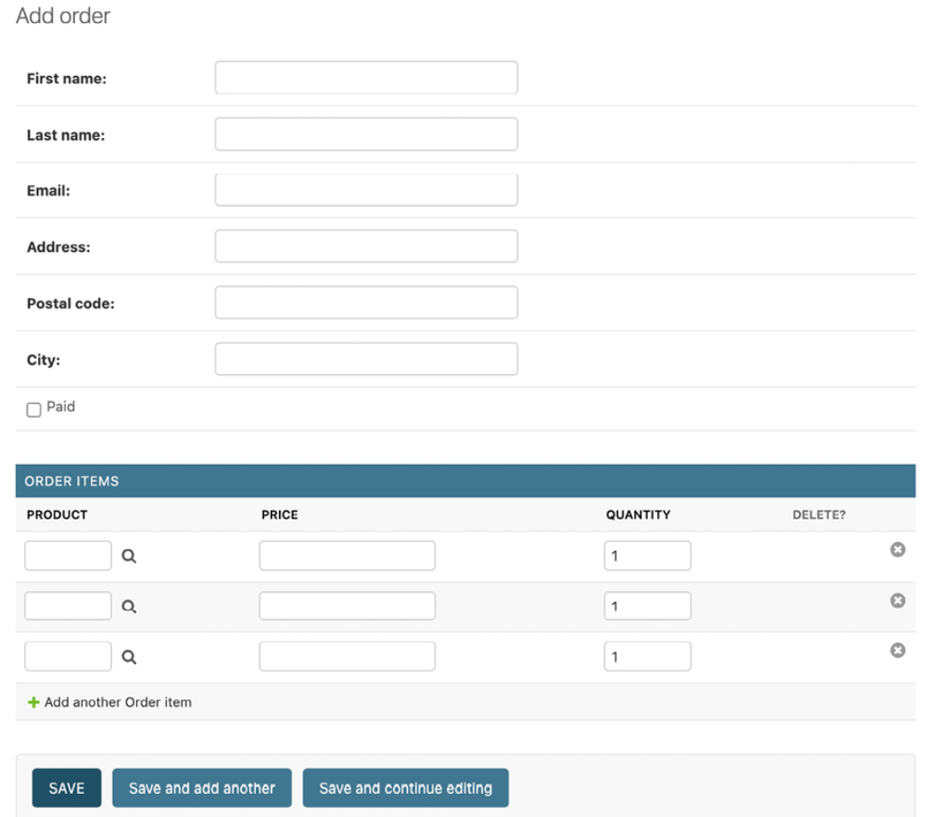
Figure 8.13: The Add order form, including OrderItemInline

Creating customer orders
You will use the order models that you created to persist the items contained in the shopping cart when the user finally places an order. A new order will be created following these steps:

1. Present a user with an order form to fill in their data.

2. Create a new Order instance with the data entered, and create an associated OrderItem instance for each item in the cart.

3. Clear all the cart’s contents and redirect the user to a success page.
First, you need a form to enter the order details. Create a new file inside the orders application directory and name it forms.py . Add the following code to it:
from django import forms
from .models import Order
class OrderCreateForm(forms.ModelForm):
class Meta:
model = Order
fields = [
'first_name',
'last_name',
'email',
'address',
'postal_code',
'city'
]

This is the form that you are going to use to create new Order objects. Now you need a view to handle the form and create a new order. Edit the views.py file of the orders application and add the following code highlighted in bold:
from cart.cart import Cart
from django.shortcuts import render
from .forms import OrderCreateForm
from .models import OrderItem
def order_create(request):
cart = Cart(request)
if request.method == 'POST':
form = OrderCreateForm(request.POST)
if form.is_valid():
order = form.save()
for item in cart:
OrderItem.objects.create(
order=order,
product=item['product'],
price=item['price'],
quantity=item['quantity']
)
# clear the cart
cart.clear()
return render(
request, 'orders/order/created.html', {'order':
)
else:
form = OrderCreateForm()
return render(
request,
'orders/order/create.html',
{'cart': cart, 'form': form}
)

In the order_create view, you obtain the current cart from the session with cart = Cart(request) . Depending on the request method, you perform the following tasks:

- GET request: Instantiates the OrderCreateForm form and renders the orders/order/create.html template.

- POST request: Validates the data sent in the request. If the data is valid, you create a new order in the database using order = form.save() . You iterate over the cart items and create an OrderItem for each of them. Finally, you clear the cart’s contents and render the template orders/order/created.html .

Create a new file inside the orders application directory and name it urls.py . Add the following code to it:
from django.urls import path
from . import views
app_name = 'orders'
urlpatterns = [
path('create/', views.order_create, name='order_create'),
]

This is the URL pattern for the order_create view.

Edit the urls.py file of myshop and include the following pattern.
Remember to place it before the shop.urls pattern, as follows. The new line is highlighted in bold:
urlpatterns = [
path('admin/', admin.site.urls),
path('cart/', include('cart.urls', namespace='cart')),
path('orders/', include('orders.urls', namespace='orders')),
path('', include('shop.urls', namespace='shop')),
]

Edit the cart/detail.html template of the cart application and find this line:
<a href="#" class="button">Checkout</a>

Add the order_create URL to the href HTML attribute, as follows:
<a href="{% url "orders:order_create" %}" class="button">
Checkout
</a>

Users can now navigate from the cart detail page to the order form.

You still need to define templates for creating orders. Create the following file structure inside the orders application directory:
templates/
orders/
order/
create.html
created.html

Edit the orders/order/create.html template and add the following code:
{% extends "shop/base.html" %}
{% block title %}
Checkout
{% endblock %}
{% block content %}
<h1>Checkout</h1>
<div class="order-info">
<h3>Your order</h3>
<ul>
{% for item in cart %}
<li>
{{ item.quantity }}x {{ item.product.name }}
<span>${{ item.total_price }}</span>
</li>
{% endfor %}
</ul>
<p>Total: ${{ cart.get_total_price }}</p>
</div>
<form method="post" class="order-form">
{{ form.as_p }}
<p><input type="submit" value="Place order"></p>
{% csrf_token %}
</form>
{% endblock %}

This template displays the cart items, including totals and the form to place an order.
Edit the orders/order/created.html template and add the following code:
{% extends "shop/base.html" %}
{% block title %}
Thank you
{% endblock %}
{% block content %}
<h1>Thank you</h1>
<p>Your order has been successfully completed. Your order number
<strong>{{ order.id }}</strong>.</p>
{% endblock %}

This is the template that you render when the order is successfully created. Start the web development server to load new files. Open http://127.0.0.1:8000/ in your browser, add a couple of products to the cart, and continue to the checkout page. You will see the following form:
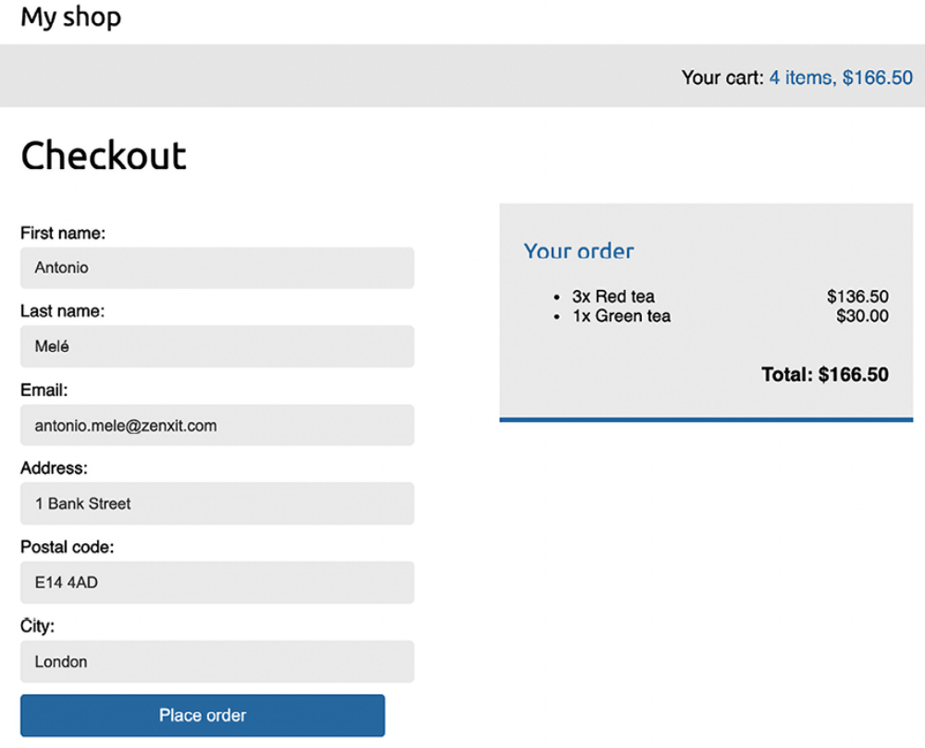
Figure 8.14: The order creation page, including the chart checkout form and order details

Fill in the form with valid data and click on the Place order button. The order will be created, and you will see a success page like this:
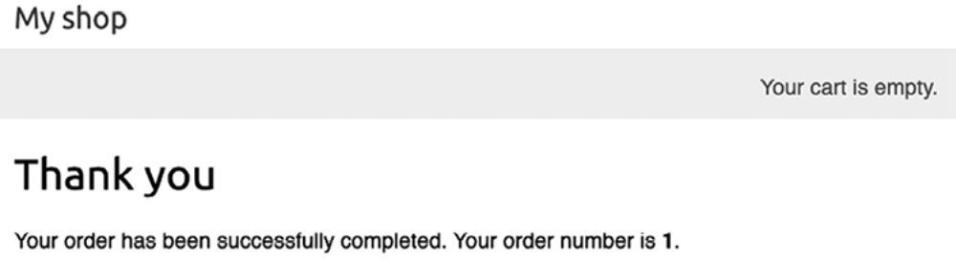
Figure 8.15: The order created template displaying the order number

The order has been registered and the cart has been cleared.

You might have noticed that the message Your cart is empty is displayed in the header when an order is completed. This is because the cart has been cleared. We can easily avoid this message for views that have an order object in the template context.

Edit the shop/base.html template of the shop application and replace the following line highlighted in bold:
...
<div class="cart">
{% with total_items=cart|length %}
{% if total_items > 0 %}
Your cart:
<a href="{% url "cart:cart_detail" %}">
{{ total_items }} item{{ total_items|pluralize }},
${{ cart.get_total_price }}
</a>
{% elif not order %}
Your cart is empty.
{% endif %}
{% endwith %}
</div>
...

The message Your cart is empty will not be displayed anymore when an order is created.

Now open the administration site at http://127.0.0.1:8000/admin/orders/order/ . You will see that the order has been successfully created, like this:
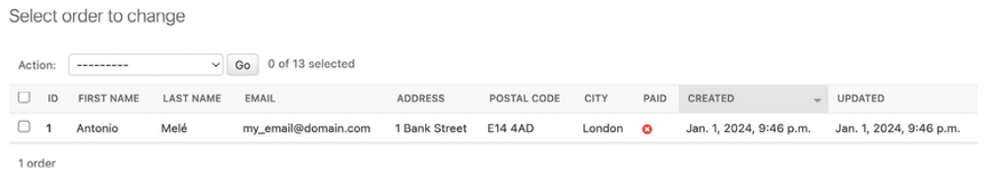
Figure 8.16: The order change list section of the administration site, including the order created

You have implemented the order system. Now you will learn how to create asynchronous tasks to send confirmation emails to users when they place an order.

Creating asynchronous tasks
When receiving an HTTP request, you need to return a response to the user as quickly as possible. Remember that in Chapter 7, Tracking User Actions, you used the Django Debug Toolbar to check the time for the different phases of the request/response cycle and the execution time for the SQL queries performed.

Every task executed during the course of the request/response cycle adds up to the total response time. Long-running tasks can seriously slow down the server response. How do we return a fast response to the user while still completing time-consuming tasks? We can do it with asynchronous execution.

Working with asynchronous tasks
We can offload work from the request/response cycle by executing certain tasks in the background. For example, a video-sharing platform allows users to upload videos but requires a long time to transcode uploaded videos. When the user uploads a video, the site might return a response informing them that the transcoding will start soon and start transcoding the video asynchronously. Another example is sending emails to users. If your site sends email notifications from a view, the Simple Mail Transfer Protocol
(SMTP) connection might fail or slow down the response. By sending the email asynchronously, you avoid blocking the code execution.

Asynchronous execution is especially relevant for data-intensive, resourceintensive, and time-consuming processes or processes subject to failure, which might require a retry policy.

Workers, message queues, and message brokers
While your web server processes requests and returns responses, you need a second task-based server, named worker, to process the asynchronous tasks. One or multiple workers can be running and executing tasks in the background. These workers can access the database, process files, send emails, and so on. Workers can even queue future tasks, all while keeping the main web server free to process HTTP requests.

To tell the workers what tasks to execute, we need to send messages. We communicate with brokers by adding messages to a message queue, which is basically a first in, first out (FIFO) data structure. When a broker becomes available, it takes the first message from the queue and starts executing the corresponding task. When finished, the broker takes the next message from the queue and executes the corresponding task. Brokers
become idle when the message queue is empty. When using multiple brokers, each broker takes the first available message in order when they become available. The queue ensures that each broker only gets one task at a time and that no task is processed by more than one worker.
Figure 8.17 shows how a message queue works:
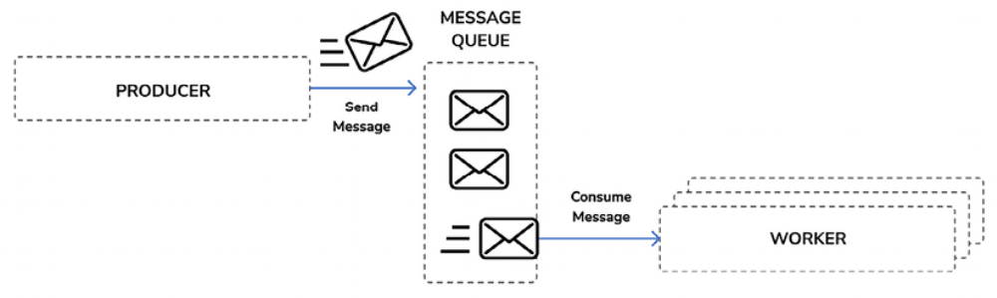
Figure 8.17: Asynchronous execution using a message queue and workers

A producer sends a message to the queue, and the worker(s) consumes the messages on a first-come, first-served basis; the first message added to the message queue is the first message to be processed by the worker(s).

In order to manage the message queue, we need a message broker. The message broker is used to translate messages to a formal messaging protocol and manage message queues for multiple receivers. It provides reliable storage and guaranteed message delivery. The message broker allows us to create message queues, route messages, distribute messages among workers, and so on.

To implement asynchronous tasks in your project, you will use Celery for managing task queues and RabbitMQ as the message broker Celery employs. Both technologies will be introduced in the following section.

Using Django with Celery and RabbitMQ
Celery is a distributed task queue that can process vast amounts of messages. We will use Celery to define asynchronous tasks as Python functions within our Django applications. We will run Celery workers that will listen to the message broker to get new messages to process asynchronous tasks.

Using Celery, not only can you create asynchronous tasks easily and let them be executed by workers as soon as possible but you can also schedule them to run at a specific time. You can find the Celery documentation at
https://docs.celeryq.dev/en/stable/index.html.

Celery communicates via messages and requires a message broker to mediate between clients and workers. There are several options for a message broker for Celery, including key/value stores such as Redis, or an actual message broker such as RabbitMQ.
RabbitMQ is the most widely deployed message broker. It supports multiple messaging protocols, such as the Advanced Message Queuing Protocol (AMQP), and it is the recommended message worker for Celery. RabbitMQ is lightweight, easy to deploy, and can be configured for scalability and high availability.

Figure 8.18 shows how we will use Django, Celery, and RabbitMQ to execute asynchronous tasks:
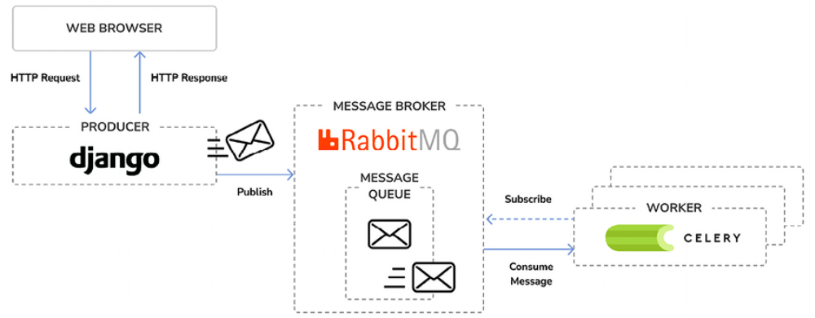
Figure 8.18: Architecture for asynchronous tasks with Django, RabbitMQ, and Celery

Installing Celery
Let’s install Celery and integrate it into the project. Install Celery via pip using the following command:
python -m pip install celery==5.4.0

You can find an introduction to Celery at
https://docs.celeryq.dev/en/stable/gettingstarted/introduction.html.

Installing RabbitMQ
The RabbitMQ community provides a Docker image that makes it very easy to deploy a RabbitMQ server with a standard configuration. Remember that you learned how to install Docker in Chapter 3, Extending Your Blog Application.

After installing Docker on your machine, you can easily pull the RabbitMQ Docker image by running the following command from the shell:
docker pull rabbitmq:3.13.1-management

This will download the RabbitMQ Docker image to your local machine. You can find information about the official RabbitMQ Docker image at
https://hub.docker.com/_/rabbitmq.

If you want to install RabbitMQ natively on your machine instead of using Docker, you will find detailed installation guides for different operating systems at https://www.rabbitmq.com/download.html.

Execute the following command in the shell to start the RabbitMQ server with Docker:
docker run -it --rm --name rabbitmq -p 5672:5672 -p 15672:15672 r

With this command, we are telling RabbitMQ to run on port 5672 , and we are running its web-based management user interface on port 15672 .

You will see output that includes the following lines:
Starting broker...
...
completed with 4 plugins.
Server startup complete; 4 plugins started.

RabbitMQ is running on port 5672 and ready to receive messages.

Accessing RabbitMQ’s management interface
Open http://127.0.0.1:15672/ in your browser. You will see the login screen for the management UI of RabbitMQ. It will look like this:
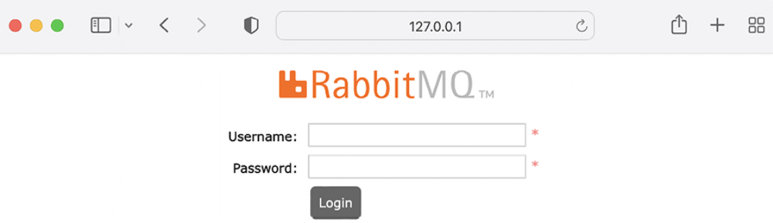
Figure 8.19: The RabbitMQ management UI login screen

Enter guest as both the username and the password and click on Login. You will see the following screen:
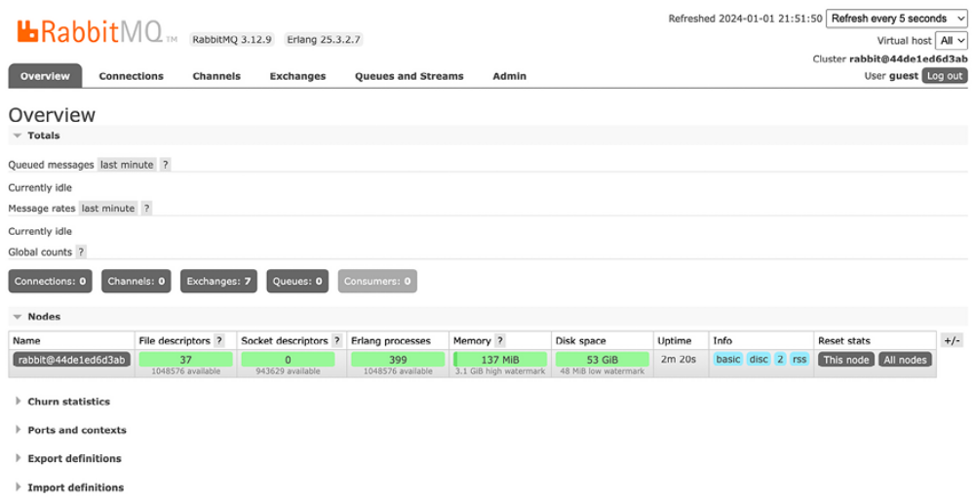
Figure 8.20: The RabbitMQ management UI dashboard

This is the default admin user for RabbitMQ. On this screen, you can monitor the current activity for RabbitMQ. You can see that there is one node running with no connections or queues registered.

If you use RabbitMQ in a production environment, you will need to create a new admin user and remove the default guest user. You can do that in the Admin section of the management UI.

Now we will add Celery to the project. Then, we will run Celery and test the connection to RabbitMQ.

Adding Celery to your project
You have to provide a configuration for the Celery instance. Create a new file next to the settings.py file of myshop and name it celery.py . This file will contain the Celery configuration for your project. Add the following code to it:
import os
from celery import Celery
# set the default Django settings module for the 'celery' progra
os.environ.setdefault('DJANGO_SETTINGS_MODULE', 'myshop.settings
app = Celery('myshop')
app.config_from_object('django.conf:settings', namespace='CELERY
app.autodiscover_tasks()

In this code, you do the following:

- You set the DJANGO_SETTINGS_MODULE variable for the Celery commandline program.

- You create an instance of the application with app = Celery('myshop') .

- You load any custom configuration from your project settings using the config_from_object() method. The namespace attribute specifies the prefix that Celery-related settings will have in your settings.py file. By setting the CELERY namespace, all Celery settings need to include the CELERY_ prefix in their name (for example, CELERY_BROKER_URL ).

- Finally, you tell Celery to auto-discover asynchronous tasks for your applications. Celery will look for a tasks.py file in each application directory of applications added to INSTALLED_APPS in order to load asynchronous tasks defined in it.

You need to import the celery module in the __init__.py file of your project to ensure it is loaded when Django starts.

Edit the myshop/__init__.py file and add the following code to it:
# import celery
from .celery import app as celery_app
__all__ = ['celery_app']

You have added Celery to the Django project, and you can now start using it.

Running a Celery worker
A Celery worker is a process that handles bookkeeping features like sending/receiving queue messages, registering tasks, killing hung tasks, tracking status, and so on. A worker instance can consume from any number of message queues.

Open another shell and start a Celery worker from your project directory, using the following command:
celery -A myshop worker -l info

The Celery worker is now running and ready to process tasks. Let’s check if there is a connection between Celery and RabbitMQ.

Open http://127.0.0.1:15672/ in your browser to access the RabbitMQ management UI. You will now see a graph under Queued messages and another graph under Message rates, as in Figure 8.21:
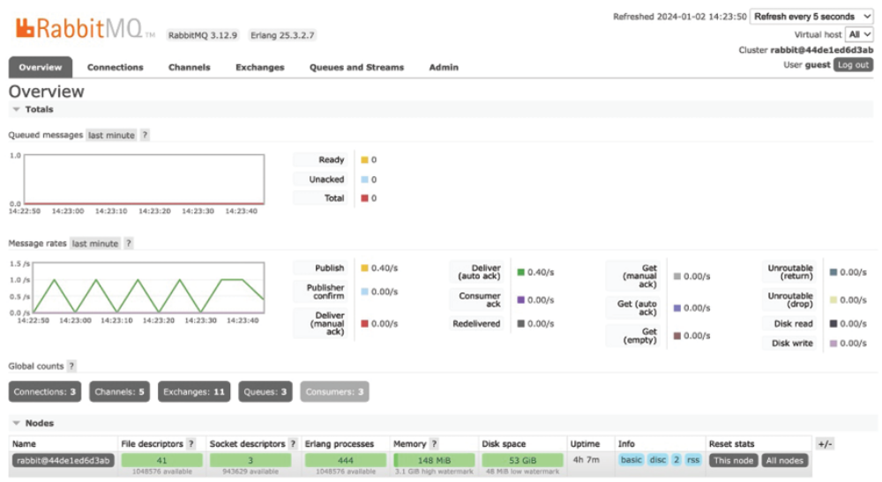
Figure 8.21: The RabbitMQ management dashboard displaying connections and queues

Obviously, there are no queued messages as we haven’t sent any messages to the message queue yet. The graph under Message rates should update every five seconds; you can see the refresh rate at the top right of the screen. This time, both Connections and Queues should display a number higher than zero.

Now we can start programming asynchronous tasks.


The CELERY_ALWAYS_EAGER setting allows you to execute
tasks locally in a synchronous manner instead of sending
them to the queue. This is useful for running unit tests or
executing the application in your local environment without
running Celery.

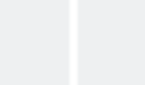

Adding asynchronous tasks to your application
Let’s send a confirmation email to the user whenever an order is placed in the online shop. We will implement sending the email in a Python function and register it as a task with Celery. Then, we will add it to the order_create view to execute the task asynchronously.

When the order_create view is executed, Celery will send the message to a message queue managed by RabbitMQ and then a Celery broker will execute the asynchronous task that we defined with a Python function.

The convention for easy task discovery by Celery is to define asynchronous tasks for your application in a tasks module within the application directory.

Create a new file inside the orders application and name it tasks.py . This is the place where Celery will look for asynchronous tasks. Add the following code to it:
from celery import shared_task
from django.core.mail import send_mail
from .models import Order
@shared_task
def order_created(order_id):
"""
Task to send an e-mail notification when an order is
successfully created.
"""
order = Order.objects.get(id=order_id)
subject = f'Order nr. {order.id}'
message = (
f'Dear {order.first_name},\n\n'
f'You have successfully placed an order.'
f'Your order ID is {order.id}.'
)
mail_sent = send_mail(
subject, message, 'admin@myshop.com', [order.email]
)
return mail_sent

We have defined the order_created task by using the @shared_task decorator. As you can see, a Celery task is just a Python function decorated with @shared_task . The order_created task function receives an order_id parameter. It’s always recommended to only pass IDs to task functions and retrieve objects from the database when the task is executed. By doing so,
we avoid accessing outdated information since the data in the database might have changed while the task was queued. We have used the send_mail() function provided by Django to send an email notification to the user who placed the order.

You learned how to configure Django to use your SMTP server in Chapter 2, Enhancing Your Blog with Advanced Features. If you don’t want to set up email settings, you can tell Django to write emails to the console by adding the following setting to the settings.py file:
EMAIL_BACKEND = 'django.core.mail.backends.console.EmailBackend'

Use asynchronous tasks not only for time-consuming processes but also for other processes that do not take so much time to be executed but that are subject to connection failures or require a retry policy.

Now you have to add the task to your order_create view. Edit the views.py file of the orders application, import the task, and call the order_created asynchronous task after clearing the cart, as follows:
# ...
from .tasks import order_created
def order_create(request):
# ...
if request.method == 'POST':
# ...
if form.is_valid():
# ...
cart.clear()
# launch asynchronous task
order_created.delay(order.id)
# ...

You call the delay() method of the task to execute it asynchronously. The task will be added to the message queue and executed by the Celery worker as soon as possible.

Make sure RabbitMQ is running. Then, stop the Celery worker process and start it again with the following command:
celery -A myshop worker -l info

The Celery worker has now registered the task. In another shell, start the development server from the project directory with the following command:
python manage.py runserver

Open http://127.0.0.1:8000/ in your browser, add some products to your shopping cart, and complete an order. In the shell where you started the Celery worker, you will see output similar to the following:
[2024-01-02 20:25:19,569: INFO/MainProcess] Task orders.tasks.ord
...
[2024-01-02 20:25:19,605: INFO/ForkPoolWorker-8] Task orders.task

The order_created task has been executed and an email notification for the order has been sent. If you are using the email backend console.EmailBackend , no email is sent but you should see the rendered text of the email in the output of the console.

Monitoring Celery with Flower
Besides the RabbitMQ management UI, you can use other tools to monitor the asynchronous tasks that are executed with Celery. Flower is a useful web-based tool for monitoring Celery. You can find the documentation for Flower at https://flower.readthedocs.io/.

Install Flower using the following command:
python -m pip install flower==2.0.1

Once installed, you can launch Flower by running the following command in a new shell from your project directory:
celery -A myshop flower

Open http://localhost:5555/ in your browser. You will be able to see the active Celery workers and asynchronous task statistics. The screen should look as follows:
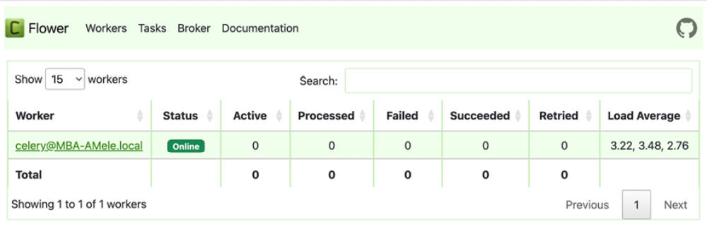
Figure 8.22: The Flower dashboard

You will see an active worker whose name starts with celery@ and whose status is Online.

Click on the worker’s name and then click on the Queues tab. You will see the following screen:
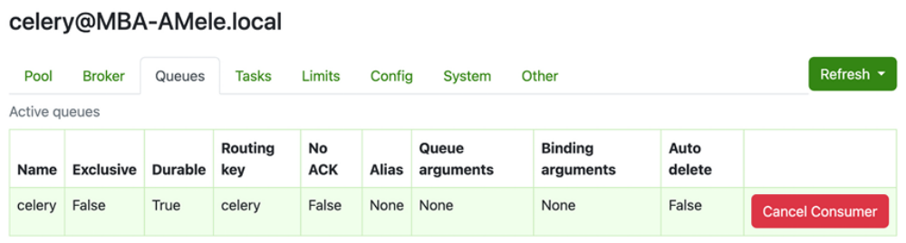
Figure 8.23: Flower – Worker Celery task queues

Here you can see the active queue named celery. This is the active queue consumer connected to the message broker.

Click the Tasks tab. You will see the following screen:
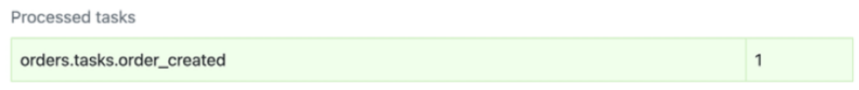
Figure 8.24: Flower – Worker Celery tasks

Here you can see the tasks that have been processed and the number of times that they have been executed. You should see the order_created task and the total times that it has been executed. This number might vary depending on how many orders you have placed.

Open http://localhost:8000/ in your browser. Add some items to the cart and then complete the checkout process.

Open http://localhost:5555/ in your browser. Flower has registered the task as processed. You should now see 1 under Processed and 1 under Succeeded as well:
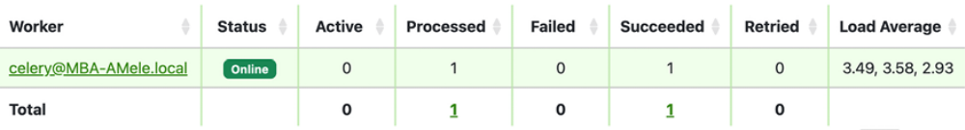
Figure 8.25: Flower – Celery workers

Under Tasks, you can see additional details about each task registered with
Celery:
Figure 8.26: Flower – Celery tasks
Flower should never be deployed openly in a production environment without security. Let’s add authentication to the Flower instance. Stop Flower using Ctrl + C, and restart it with the --basic-auth option by executing the following command:
celery -A myshop flower --basic-auth=user:pwd

Replace user and pwd with your desired username and password. Open http://localhost:5555/ in your browser. The browser will now prompt you for credentials, as shown in Figure 8.27:
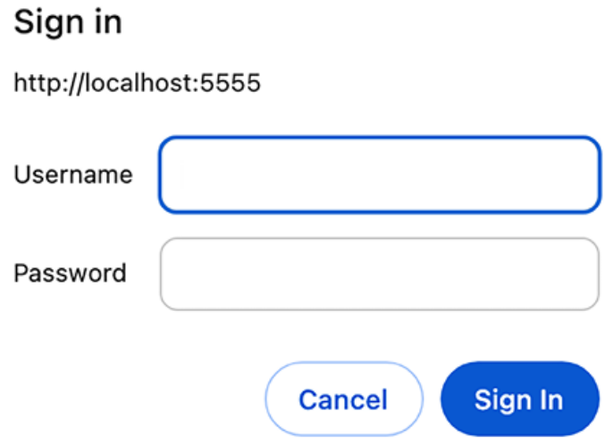
Figure 8.27: Basic authentication required to access Flower

Flower provides other authentication options, such as Google, GitHub, or Okta OAuth. You can read more about Flower’s authentication methods at
https://flower.readthedocs.io/en/latest/auth.html.

Summary
In this chapter, you created a basic e-commerce application. You made a product catalog and built a shopping cart using sessions. You implemented a custom context processor to make the cart available to all templates and created a form for placing orders. You also learned how to implement asynchronous tasks using Celery and RabbitMQ. Having completed this chapter, you now understand the foundational elements of building an ecommerce platform with Django, including managing products, processing orders, and handling asynchronous tasks. You are now also capable of developing projects that efficiently process user transactions and scale to handle complex background operations seamlessly.

In the next chapter, you will discover how to integrate a payment gateway into your shop, add custom actions to the administration site, export data in CSV format, and generate PDF files dynamically.
Additional resources
The following resources provide additional information related to the topics covered in this chapter:
Source code for this chapter: ( See page 615 )

